Conducted Emission Test Report

Contents

1. Test lab facility 2

Test Site: 2

Facility name: 2

Facility address: 2

Facility site description: 2

Test Standards 2

EMC Directive 2014/30/EU 2

Test Equipment: 2

Environmental conditions: 2

Test Operator and Date: 2

2. Product Information 2

3. EUT setup 2

Photograph of EUT: 2

4. Test Result 2

5. Summary 2

# Test lab facility

## Test Site:

Facility name: Keysight Technology, Technology Order Fulfillment, Colorado Springs Hardware Test Center.

Facility address: 1900 Garden of the Gods Rd, Colorado Springs, CO. 80920

Facility site description:

The Keysight Technologies Technology Order Fulfillment Colorado Spring Hardware Test Center is a certified radiated interference testing facility, which is comply with the standard requirements defined by IEC 61326.

## Test Standards

### EMC Directive 2014/30/EU

IEC 61326-1:2012 / EN 61326-1:2013 (Basic) Radiated Emission Reference Standards:

CISPR 11:2009+A1:2010 / EN 55011:2009+A1:2010 Group 1 Class A. The products were tested in a typical configuration with Keysight Technologies test systems. This product is intended for use in a basic electromagnetic environment.

## Test Equipment:

|  |  |
| --- | --- |
| MXE Receiver address | USB0::0x0957::0x0f0b::MY52130013::0::INSTR |
| LISN Model | EMCO 4825/2 |
| LISN SN | SN:00130174 |
| Power Limiter Calibration | 5/1/2016 |
| Test Standard | CISPER 11 Group 1 Class A RE |
| Test Site | Colorado Springs TOF Hardware Test Center 3 Meter anechoic chamber |
| Test Voltage | 110V |

## Environmental conditions:

Temperature: 72°F; Humidity :50 RH

Note: There will be no effect to the result due to changes in mains voltage or frequency.

## Test Operator and Date:

Operator: Clifford; Report generated at: May.19,2016 9:09:31 AM

# Product Information

|  |  |
| --- | --- |
| Product Name: | Ursa |
| Product Model: | 16862A |
| Product SN: | 105 |
| Project Stage: | LP1/PP |
| Deliver date of the test samples: | 5/9/2016 |
| DUT power: | Main |
| Auxiliary equipment list: | HP Keyboard and Mouse |
| Model numbers covered by the test: | 16864A, 16862A |
| .-Hardware Difference | 4 channel and 2 channel |
| .-Software/firmware difference: | Same |
| .-Cosmetic difference: | Label is different |
| Test Configuration | Test configuration is acquizaiton mode waiting for trigger |

# EUT setup

## Photograph of EUT:

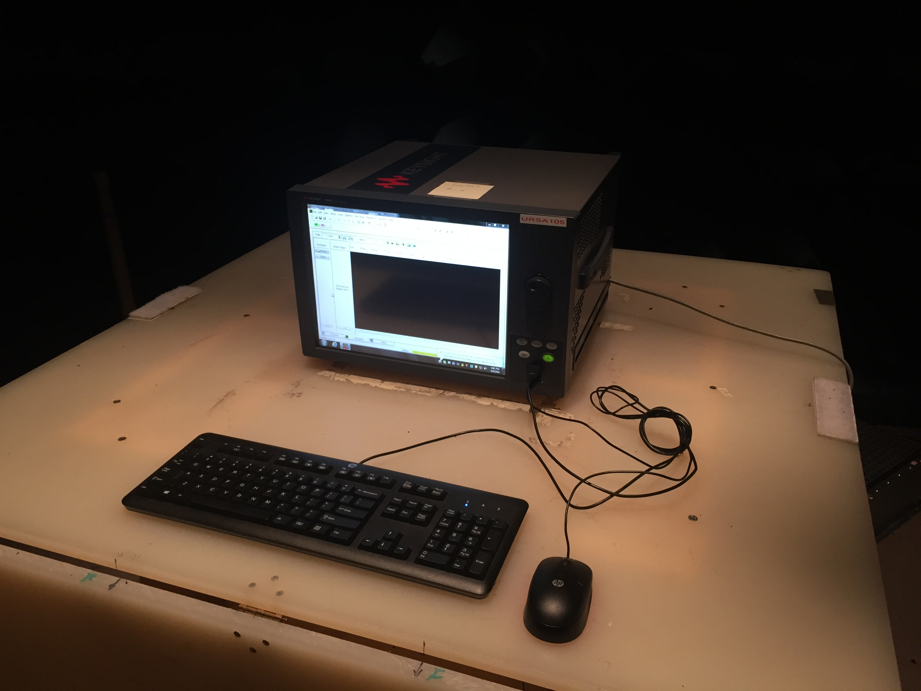

# Test Result

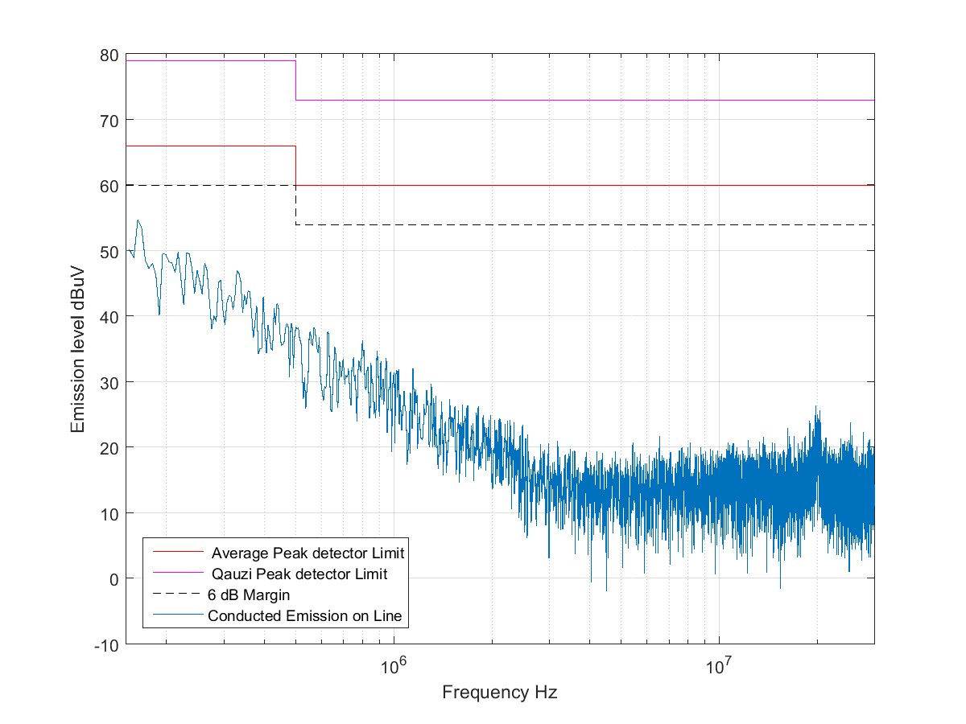

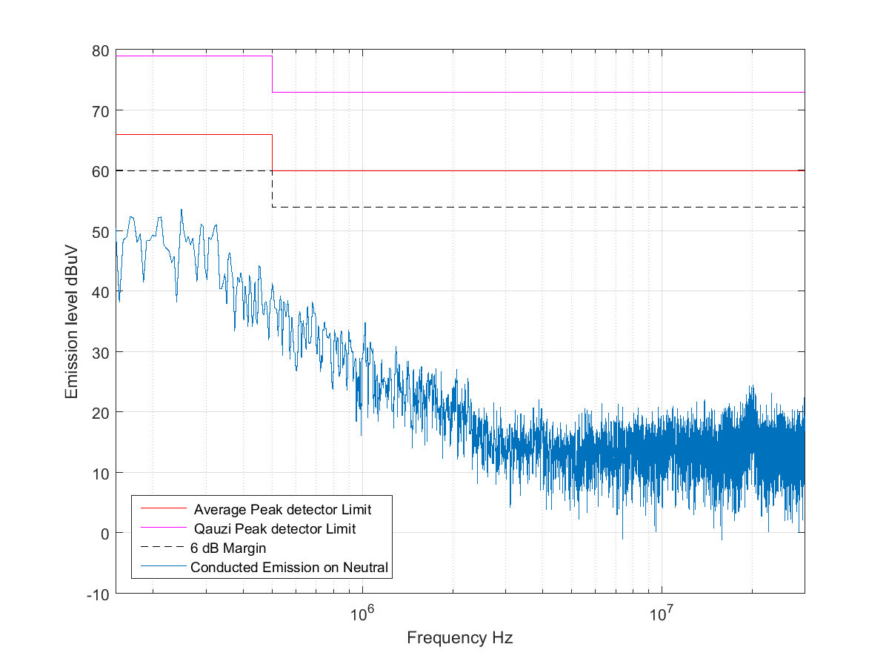

# Summary

The unit Passed the Conducted Emission Test in Line wire!

The unit passed the Conducted Emission Test in Neutrual wire!